**Programming Assignment Unit 3**

ANGELLA BENJAMIN

Bachelor's degree in Computer Science

CS 1101-01 Programming Fundamentals - AY2024-T2

Madhukeshwar Khanapur (Instructor)

05th December 2023

**Q.1 Part1:**  Recursive function countup that expects a negative argument and counts “up” from that number

The code below includes a function called countup that accepts an argument n. If the value of n is greater than or equal to 0, the function will print 'Blastoff!'. However, if the value of n is not 0, it will first print the value of n. In this example, the initial value of n is -3. The function then calls itself with n+1 as the argument, which increments n by 1. This process continues until n reaches 0, at which point 'Blastoff!' is printed because the condition n >= 0 is satisfied. Therefore, when countup(-3) is called, the output will be -3, -2, -1, and 'Blastoff!' in that order.

**Code.** For direct acess of my Code please visit Get here on My Github codespace

#recursive function countup

def countup(n):

    if n >= 0:

        print('Blastoff!')

    else:

        print(n)

        countup(n + 1)

countup(-3)

**Output**

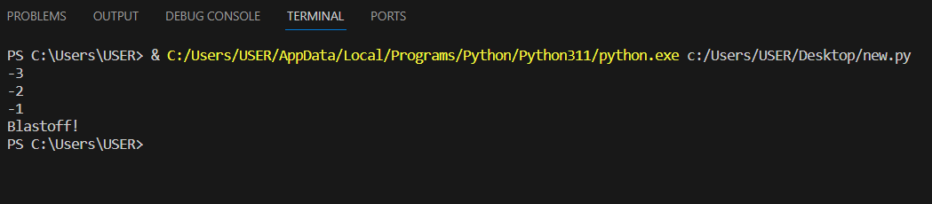

**Part 2:** Write a Python program that gets a number using keyboard input.

In this part of the assignment, I have implemented two versions of the code that essentially yield the same result. I was intrigued and decided to explore different approaches.

In the first code, I created a single function and used n == 0 as the condition to determine the behavior. If the sum of any number and n is equal to 0, the function will print "Blastoff!". If the number is greater than 0, the function will print the current value of n and recursively call itself with n - 1, decrementing n until it reaches 0 and then print "Blastoff!" since the condition is satisfied. Conversely, if the number is less than 0, the function will print the current value of n and recursively call itself with n + 1, incrementing n until it equals 0 and then print "Blastoff!".

This is a simplified approach I used to write the program with a single function to handle both countdown and count up. It is important to note that the value of n is obtained through user input. Therefore, the function counts up or down based on the number entered by the user.

**Here is the First code of implementation:**

def countdown_up(n):

    if n == 0:

        print('Blastoff!')

    elif n > 0:

        print(n)

        countdown_up(n - 1)

    else:

        print(n)

        countdown_up(n + 1)

n = int(input("Enter the number you want to count Up or Down: "))

countdown_up(n)

By executing this code, the program prompts the user to enter a number, and based on the input, it will either count up or down until it reaches 0 and then print "Blastoff!".

**Code 2**

In the second code, I have defined two functions, each with its own set of arguments. The countup function takes n >= 0 as the argument condition. If the number is equal to or greater than n, it prints "Blastoff!". If the number is less than or equal to n, it adds 1 to the number until it reaches 0 and then prints "Blastoff!". The countdown function follows a similar logic but in reverse.

The challenge with this code is that it prints "Blastoff!" twice for the two functions. Additionally, sometimes you have to specify which function you want to call. Personally, I find the first function more convenient.

**Here is the code implementation 2:**

def countup(n):

    if n >= 0:

        print('Blastoff!')

    else:

        print(n)

        countup(n + 1)

def countdown(n):

    if n <= 0:

        print('Blastoff!')

    else:

        print(n)

        countdown(n - 1)

n = int(input("Enter Number you want to count:"))

if n >= 0:

    countdown(n)

elif n < 0:

    countup(n)

countdown(n) or countup(n)

**Reference:**

<https://my.uopeople.edu/pluginfile.php/1807616/mod_page/content/4/TEXT%20-%20Think%20Python%202e.pdf>

<https://pythonprogramminglanguage.com/user-input-python/>

<https://realpython.com/python-recursion/>

<https://realpython.com/python-recursion/#get-started-count-down-to-zero>